import numpy as np
import pandas as pd
import matplotlib.pyplot as plt
from sklearn.linear_model import LinearRegression

url = "https://raw.githubusercontent.com/vincentarelbundock/Rdatasets/master/csv/MASS/birthwt.csv"
df = pd.read_csv(url)

df.columns = df.columns.str.strip().str.lower()
print("Columns:", df.columns.tolist())

def calc_covariance(dataset1, dataset2):
mean1 = np.mean(dataset1)
mean2 = np.mean(dataset2)
return np.sum((dataset1 - mean1) * (dataset2 - mean2)) / len(dataset1)

def correlation(dataset1, dataset2):
cov = calc_covariance(dataset1, dataset2)
sd1 = np.std(dataset1)
sd2 = np.std(dataset2)
return cov / (sd1 * sd2)

age = df["age"].to_numpy()
birthwt = df["bwt"].to_numpy()

corr_age_bwt = correlation(age, birthwt)
print("Correlation (Mother's Age vs Birth Weight):", corr_age_bwt)

lr = LinearRegression()
lr.fit(age.reshape(-1, 1), birthwt)
y_pred_age = lr.predict(age.reshape(-1, 1))

plt.figure(figsize=(6, 4))
plt.scatter(age, birthwt / 1000, color="green")
plt.plot(age, y_pred_age / 1000, color="red")
plt.xlabel("Mother's Age")
plt.ylabel("Birth Weight (Kg)")
plt.title("Mother's Age vs Birth Weight")
plt.grid(True)
plt.show()

motherswt = df["lwt"].to_numpy()
birthwt_kg = birthwt / 454

corr_wt_bwt = correlation(motherswt, birthwt_kg)
print("Correlation (Mother's Weight vs Birth Weight):", corr_wt_bwt)

lr2 = LinearRegression()
lr2.fit(motherswt.reshape(-1, 1), birthwt_kg)
y_pred_wt = lr2.predict(motherswt.reshape(-1, 1))

plt.figure(figsize=(6, 4))
plt.scatter(motherswt, birthwt_kg, color="darkblue")
plt.plot(motherswt, y_pred_wt, color="orange")
plt.xlabel("Mother's Weight (pounds)")
plt.ylabel("Birth Weight (pounds)")
plt.title("Mother's Weight vs Birth Weight")
plt.grid(True)
plt.show()

OUTPUT:
Columns: ['rownames', 'low', 'age', 'lwt', 'race', 'smoke', 'ptl', 'ht', 'ui', 'ftv', 'bwt']
Correlation (Mother's Age vs Birth Weight): 0.0903178136685326
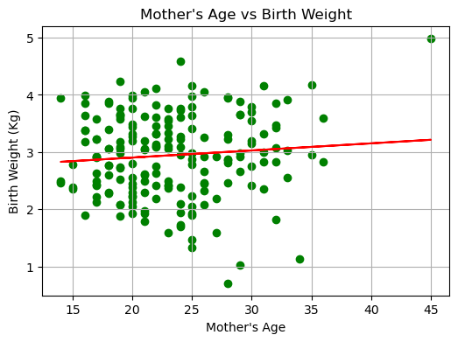
Correlation (Mother's Weight vs Birth Weight): 0.18573328444909923
